DASHBOARD

py -m pip install plotly-express
py -m pip install streamlit

PASSO 1: Ler os dados do ficheiro Excel

import pandas as pd # pip install pandas openpyxl
import plotly.express as px # pip install plotly-express
import streamlit as st # pip install streamlit
import os

nome_ficheiro_excel = 'supermercado_vendas.xlsx'

# Obter a pasta onde está o ficheiro .py
diretorio_script = os.path.dirname(os.path.abspath(__file__))

# Construir o caminho completo para o ficheiro CSV
caminho_completo_ficheiro = os.path.join(diretorio_script, nome_ficheiro_excel)

df = pd.read_excel(
io=caminho_completo_ficheiro,
engine="openpyxl",
sheet_name="Vendas",
skiprows=3,
usecols="B:R",
nrows=1000,
)

df["hour"] = pd.to_datetime(df["Time"], format="%H:%M:%S").dt.hour

st.write(df)

streamlit run (caminho até ao ficheiro app.py)

streamlit run c:\a\app.py

http://localhost:8501

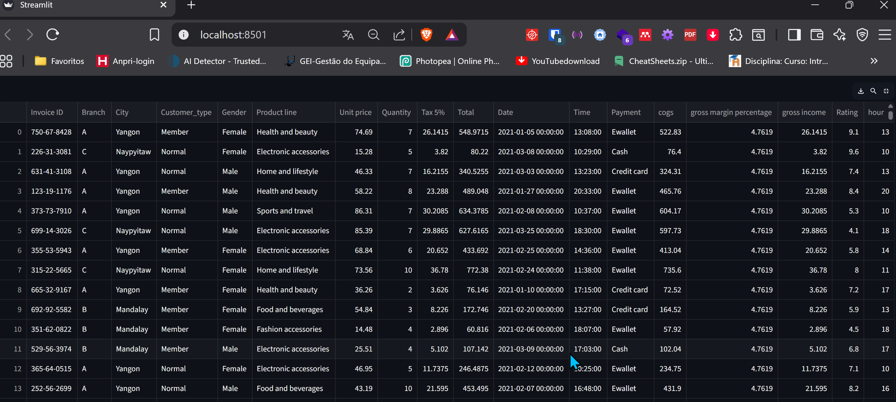

PASSO 2: Barra lateral (sidebar)

# ---- SIDEBAR ----
st.sidebar.header("Please Filter Here:")
city = st.sidebar.multiselect(
"Select the City:",
options=df["City"].unique(),
default=df["City"].unique()
)

customer_type = st.sidebar.multiselect(
"Select the Customer Type:",
options=df["Customer_type"].unique(),
default=df["Customer_type"].unique(),
)

gender = st.sidebar.multiselect(
"Select the Gender:",
options=df["Gender"].unique(),
default=df["Gender"].unique()
)

df_selection = df.query(
"City == @city & Customer_type ==@customer_type & Gender == @gender"
)

# Check if the dataframe is empty:
if df_selection.empty:
st.warning("No data available based on the current filter settings!")
st.stop() # This will halt the app from further execution.

http://localhost:8501

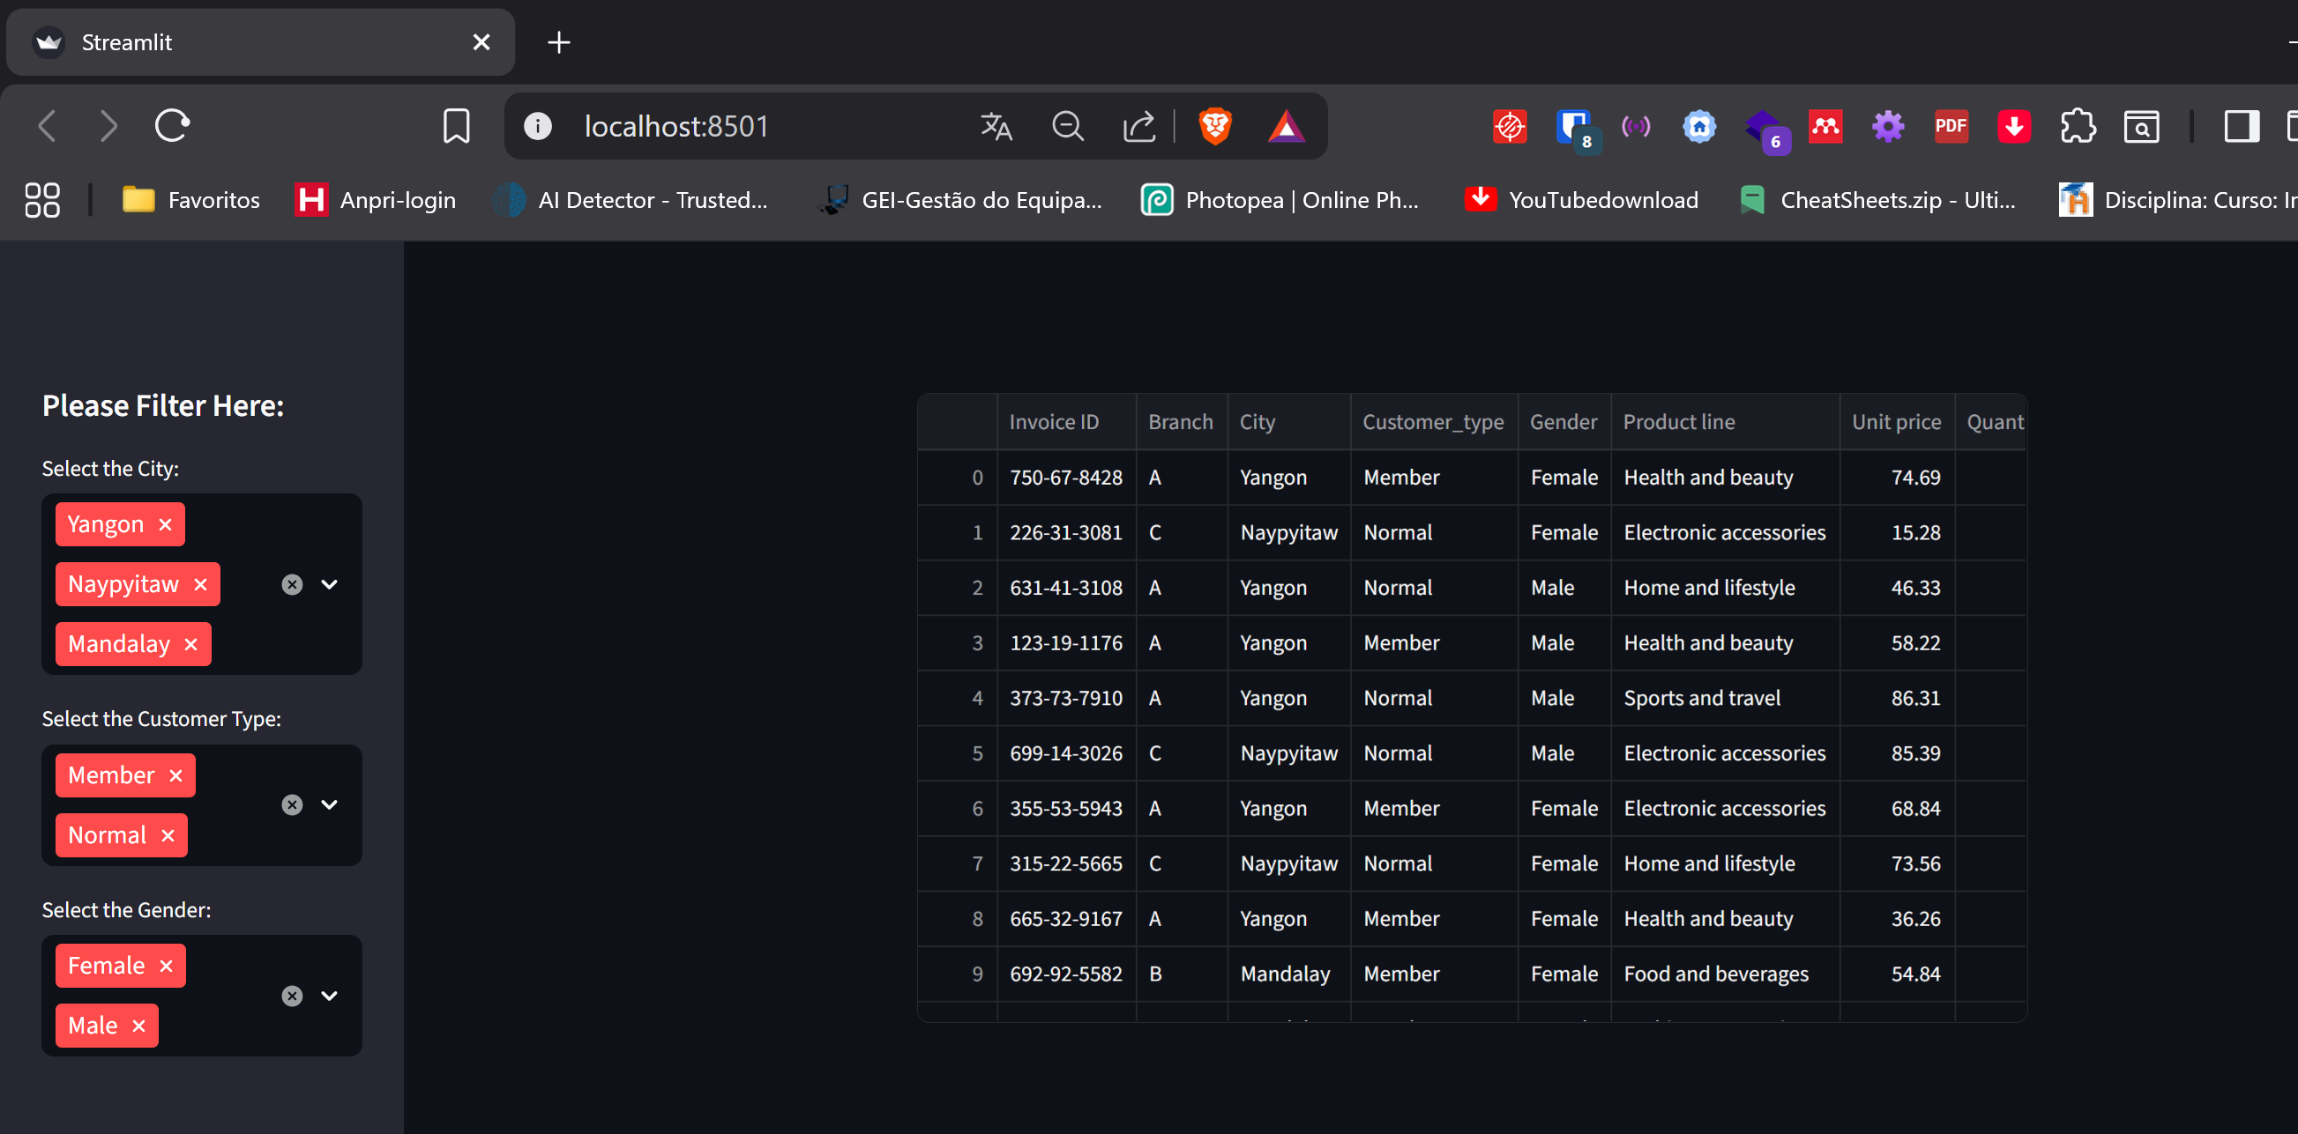

PASSO 3:

# ---- MAINPAGE ----
st.title(":bar_chart: Vendas Dashboard")
st.markdown("##")

# TOP KPI's
total_sales = int(df_selection["Total"].sum())
average_rating = round(df_selection["Rating"].mean(), 1)
star_rating = ":star:" * int(round(average_rating, 0))
average_sale_by_transaction = round(df_selection["Total"].mean(), 2)

left_column, middle_column, right_column = st.columns(3)
with left_column:
st.subheader("Total Vendas:")
st.subheader(f"€ {total_sales:,}")
with middle_column:
st.subheader("Média ratting:")
st.subheader(f"{average_rating} {star_rating}")
with right_column:
st.subheader("Média de vendas por transação:")
st.subheader(f"€ {average_sale_by_transaction}")

st.markdown("""---""")

# SALES BY PRODUCT LINE [BAR CHART]
sales_by_product_line = df_selection.groupby(by=["Product line"])[["Total"]].sum().sort_values(by="Total")
fig_product_sales = px.bar(
sales_by_product_line,
x="Total",
y=sales_by_product_line.index,
orientation="h",
title="<b>Sales by Product Line</b>",
color_discrete_sequence=["#0083B8"] * len(sales_by_product_line),
template="plotly_white",
)
fig_product_sales.update_layout(
plot_bgcolor="rgba(0,0,0,0)",
xaxis=(dict(showgrid=False))
)

# SALES BY HOUR [BAR CHART]
sales_by_hour = df_selection.groupby(by=["hour"])[["Total"]].sum()
fig_hourly_sales = px.bar(
sales_by_hour,
x=sales_by_hour.index,
y="Total",
title="<b>Sales by hour</b>",
color_discrete_sequence=["#0083B8"] * len(sales_by_hour),
template="plotly_white",
)
fig_hourly_sales.update_layout(
xaxis=dict(tickmode="linear"),
plot_bgcolor="rgba(0,0,0,0)",
yaxis=(dict(showgrid=False)),
)

left_column, right_column = st.columns(2)
left_column.plotly_chart(fig_hourly_sales, use_container_width=True)
right_column.plotly_chart(fig_product_sales, use_container_width=True)

# ---- HIDE STREAMLIT STYLE ----
hide_st_style = """
<style>
#MainMenu {visibility: hidden;}
footer {visibility: hidden;}
header {visibility: hidden;}
</style>
"""
st.markdown(hide_st_style, unsafe_allow_html=True)

http://localhost:8501

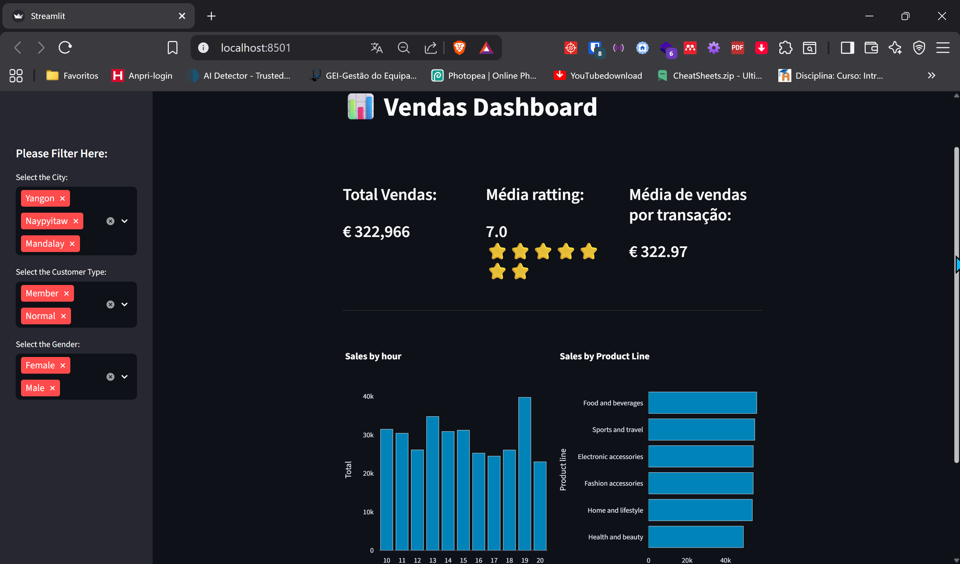

PASTA:  com as configurações de cores.

